Kipawa Lodge
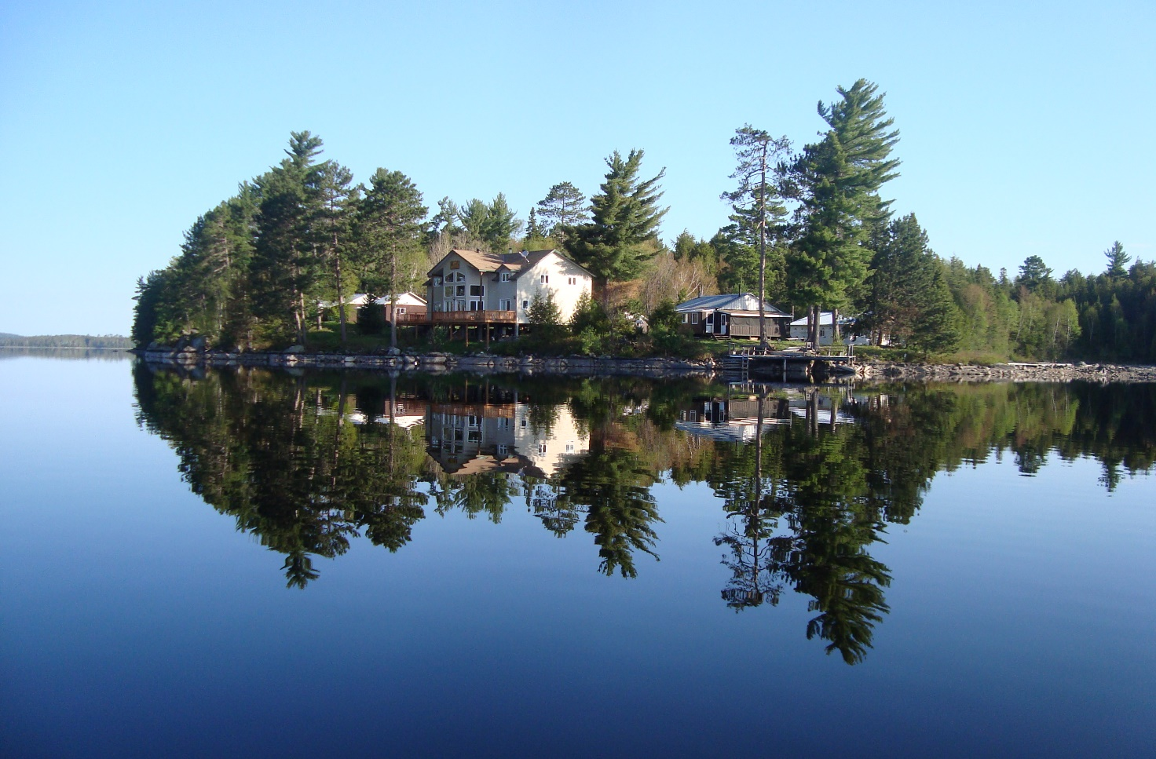

Welcome to Kipawa Lodge your home away from home for the next little while. We’ve done our best to give you a clean comfy place to kick back, relax, make yourself at home, enjoy the fishing, the tranquility, and above all the
company. If we have missed anything, please let us know!
Wayne and Barb

Index
Planning your Trip 3
Useful information 3
Arrival and departure 4
Payments and Deposit 4
Safety and Emergency 5
Cabin Rules 6
Kitchens 7
Bathrooms 8
Stay Connected 8
Docking 8
Rental Boats 9
Water Toys 10
Lake Water 10
Pets 10
Fish Cleaning 10
Fishing Regulations 11
Fishing Logs 11
Departure 12
What to Pack……………………………………………………………..…………………………………………13

Planning your Trip

Useful information
Please call from North Bay or Mattawa to confirm your pickup time: 1-877-454-7292.
If you forget to call you may be waiting longer than expected.

Motel accommodations:
- North Bay (1 hour away)
- Temiscaming (15 minutes away):
  - Motel Tem Rose, 819-627-1250
  - Motel AuBercail, 819-627-3476

Stores:
- Grocery store, IGA, 201 Rue de la Falaise, Temiscamingue, Quebec
- SAQ (liquor store), 534 Chemin de Kipawa, Temiscamingue, Quebec
- Fishing Licences and Bait can be purchase at Pronature, 1625 Chemin de Kipawa, Temiscamingue, 819-627-9432 and the Zec Office
- Licences can now be purchased on -line @ www.mondossierchassepeche.gouv.qc.ca/en

Parking:
- Address: 560 Chemin de la Baie de Kipawa, Kipawa, Quebec, J0Z 2H0, blue house across from dock, see Mary. Parking is subject to a fee.

Arrival and departure
Check-in Saturday, 1pm
Check-out Friday, 9am

Payments and Deposit
Deposit of $100 per person or a minimum of $500/cabin required at time of booking.
Deposit can be made by American Express, Discover, Visa, Mastercard, Debit, e-transfer or cash. Sorry, no personal cheques.

Deposits are non-refundable.

Safety and Emergency
- If you are new to the lake, tell someone what your plans are before heading out on the water. If you are late returning, we know where to find you.
- In case of emergency please have someone from your group immediately ring the emergency bell located on the back porch of the main lodge.
- First aid supplies are available for minor injuries.
- Fire extinguishers are located on the wall in kitchen area of each cabin, and on main docks.
- Beer on the Peer, Water on the Water.
- Boaters card is required for kids 16 and older to operate our rental boats. Under 16, with Mom or Dad only.
- Always leave a contact number with family. Each year we receive calls from frantic family members trying to locate loved ones.
- If you are out on the lake and hear thunder, please come back to camp as soon as possible. If you get caught in the storm and are unable to get to the lodge try to reach the shore and stay there.

Cabin Rules
- Please do no smoke inside cabin. Cigarettes butts should be disposed in a safe manner. Not, on the ground where a chance of fire could occur.
- Your cabin has been thoroughly cleaned, please leave it clean.
- Quiet time between 10pm-7am.
- Fish cleaning in fish house only.
- Please keep garbage and recycling separate.
- Place garbage outside for pick up.
- Place beer bottles back into cases and take them home with you.
- Dispose of cooking oil only after it has cooled. Containers are located beside Fish House.
- Never, ever pour water on a grease fire! It will explode!
- Our electricity is solar power. Please turn off all lights when not in use and do not plug anything in. If the battery bank becomes drained, we will have no water and no refrigeration. Radios are permitted but please no electric appliances. Battery powdered fans only.
- Barbecues and fish fryers are to be used outside. Not on porch!

Kitchens
- Your kitchen is well equipped with the necessary tools. If you are missing something, please let us know. We can get that for you.
- Cook stove is propane. The burners and ovens operate on pilots. To turn on burners push in knob before turning. If you are having difficulty, please see us.
- Please do not store flats of worms in fridge. They do escape and make a HUGE mess. Coolers are available if needed.
- Ants and rodents just love a nice free buffet. If you leave food out, they will find it.
- Please help us reduce waste by composting vegetable peelings, eggshells, coffee grounds and any fruits or vegetables.
- Food waste containing meat, cheese, fish, poultry, or bones can be disposed of in the fish house.
- Cooking oil can be disposed of in designated containers once cooled.
- Propane grills are to be used outside only. Please turn off tank after each use.
- Please do not use duct tape on any surface. It is almost impossible to remove the glue and does damage to finishes.

Bathrooms
We have provided the following amenities for your stay,
- Toilet paper
- Shower mat

Forgot something? Maybe we can help you with that?

Stay Connected
Complimentary Wi-Fi available at main lodge.
Network: Kipawa-Guest
Password: gonefishing
Network: Kipawa
Password: Kipithebear
Please note: Due to our remote location, unlimited internet is not available. Therefore, we ask that you limit your usage and refrain from streaming!

Docking
- Docks will be designated for each rental as well as private boats. Please do not park in someone else slip.
- Gas is provided for rental boats only. If you need gas for your personal boat, please see a member of our staff.
- For safety reasons, please slow down when nearing docks, boats, swimmers, and water toys.

Rental Boats
- Our fishing maps show fishing spots as well as shallow waters and shoals. Please, stay well away from shallow water. If you accidently hit the motor, please let us know immediately.
- Your rental boat has been cleaned and fueled.
- Please keep it clean. That means, no garbage, dead bait, beer cans or cigarette buts.
- If you get fishing line caught in the prop, let us know. It is an easy fix and can prevent serious damage.
- Please do not tinker or adjust motors. If you are having issues with your boat or motor, please see a staff member.
- If you get your anchor caught on bottom, do not cut the rope. Tie the rope to the float inside the safety kit and make note of your location. Wayne will retrieve it. Never go out on the water without an anchor.

Water Toys
Canoes, kayaks, paddle boards are available at no charge. If you use them, please return them to the designated area. Lifejackets must be worn, it is the law!

Lake Water
Lake water is suitable for cooking and consuming only if it has been boiled. We recommend bringing bottled water for drinking.

Pets
We know how much you love your cute cuddly and adorable pet. They are family and you want to bring them with you wherever you go. Due to our strict cleaning policies and allergies, we are unable to welcome any pet of any size.

Fish Cleaning
Fish cleaning is to be done in fish cleaning house only. Please put entrails in pails, rinse counter and turn off lights. No garbage in buckets. The gulls, eagles and vultures will thank you for that.
Fishing regulations as well as methods for transport are posted in the fishing cleaning house as well as each cabin.

Fishing Regulations
Lake Kipawa has an outstanding fishery. Fishing regulations regarding sizes and limits are put into place to keep it that way. Please follow all rules. The wardens are on the lake and will be checking!
Fish | Limit per licence | Size
Walleye | 6 | Between 37cm-53cm
Lake trout | 1 | Min 65cm
Northern Pike | 6 | No size limit
Bass | 6 | No size limit

Please note:
- Minnows are not permitted, dead or alive.
- Only fish with 1 fishing rod per person
- No bait can be imported into Canada

For more information regarding fishing regulations, please visit: https://www.quebec.ca/en/tourism-and-recreation/sporting-and-outdoor-activities/sport-fishing/zones-periods/particular-rules/zone-13

Fishing Logs
At the end of each season, we are required by law to submit an “Activities Report”, to the Quebec government. This report must include species, fish caught, fish consumed, and fish transported home as well as guest numbers. Please take time each day to record your catch on the supplied fish log. This will help us to be as accurate as possible.

Departure
Check-out Friday, 9am
When checking out please ensure your cabin is clean and all food removed. Don’t forget your phone, your keys, and your kids!
We hope you enjoyed your time with us. If not, please let us know how we can improve.
If we did a good job, please don’t be shy and let everyone know.
Reviews on Facebook, Google or Tripadvisor are always appreciated!
Follow us on Facebook

What to Pack
- Fishing Gear
- Clothing suitable for all weather
- Rain Gear
- Freezer bags
- Paper towels
- Sleeping bag and pillow
- Bath towels
- Filet knife
- Flashlight
- Matches or lighter
- Dish cloth, towels, and dish soap
- Disinfectant wipes and hand sanitizer

What we Supply:
- Garbage bags
- Firewood
- Toilet paper
- Bars of soap

