**Kipawa Lodge**

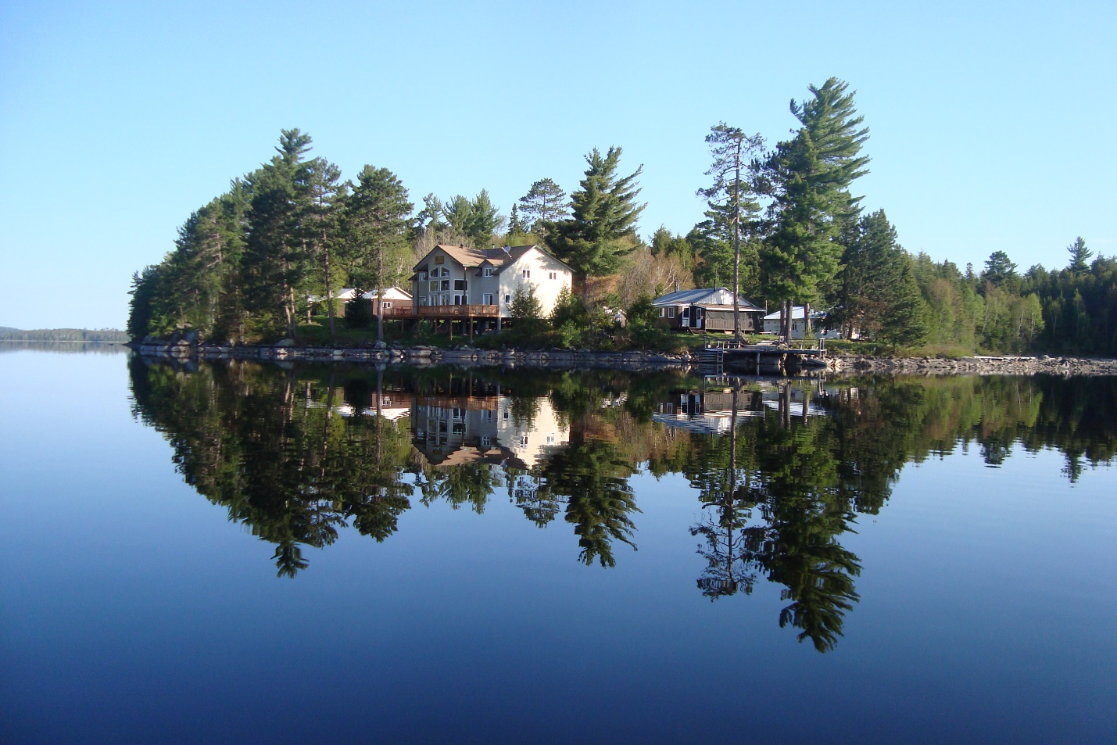

Welcome to Kipawa Lodge your home away from home for the next little while. We’ve done our best to give you a clean comfy place to kick back, make yourself at home, enjoy the fishing, the tranquility, and above all the

company. If we have missed anything, please let us know!

*Wayne and Barb*

# Planning your Trip

* Please call from North Bay or Mattawa to confirm your pickup time. 1-877-454-7292
* Motel accommodations,
* North Bay(1 hour away)
* Temiscamingue(15 minutes away), Motel Tem Rose, 819-627-1250

Motel AuBercail, 819-627-3476

* Grocery store, IGA, 201 Rue de la Falaise, Temiscamingue, Québec
* SAQ(liquor store), 534 Chemin de Kipawa, Témiscamingue, Quebec
* Fishing Licences and Bait can be purchase at Pronature, 1625 Chemin de Kipawa, Temiscamingue, 819-627-9432
* Parking, 557 Chemin de la Baie de Kipawa, J0Z 2H0, blue house across from dock, see Mary. Parking is subject to a fee.

## Arrival and departure

Check-in Saturday, 1pm

Check-out Friday, 9am

When checking out please ensure your cabin is clean and all food removed. Don’t forget your phone, your keys, and your kids!

We hope you enjoyed your time with us. If not, please let us know how we can improve.

If we did a good job, please don’t be shy and let everyone know.

Reviews on Facebook, Google or Tripadvisor are always appreciated!

# Safety and Emergency

* If you are new to the lake, tell someone what your plans are before heading out on the water. If you are late returning, we know where to find you.
* In case of emergency please have someone from your group immediately ring the emergency bell located on the back porch of the main lodge.
* First aid supplies are available for minor injuries.
* Fire extinguishers are located on the wall in kitchen area of each cabin, and on main docks.
* Beer on the Peer, Water on the Water

## Stay Connected

Complimentary Wi-Fi available at main lodge.

Network….Kipawaguest

Password…gonefishing

Please note: Due to our remote location, unlimited internet is not available. Therefore, we ask that you limit your usage and refrain from streaming!

Lake Water

Lake water is suitable for cooking and consuming only if it has been boiled. We recommend bringing bottled water for drinking.

## Cabin Rules

* Please do no smoke inside cabin. Cigarettes butts should be disposed in a safe manner.

not on the ground where a chance of fire could occur.

* Your cabin has been thoroughly cleaned, please leave it clean.
* Quiet time between 10pm-7am.
* Fish cleaning in fish house only.
* Please keep garbage and recycling separate.
* Place garbage outside for pick up.
* Place beer bottles back into cases and take them home with you.
* Dispose of cooking oil only after it has cooled. Containers are supplied.
* Never, ever pour water on a grease fire! It will explode!
* Our electricity is solar power. Please turn off all lights when not in use and do not plug anything in. If the battery bank becomes drained, we will have no water and no refrigeration.
* Barbecues and fish fryers are to be used outside. Not on porch.

## Kitchens

* Your kitchen is well equipped with the necessary tools. If you are missing something, please let us know. We can get that for you.
* Cook stove is propane. The burners and ovens operate on pilots. To turn on burners push in knob before turning. If you are having difficulty, please see us.
* Please do not store flats of worms in fridge. They do escape and make a BIG mess! Coolers are available if needed.
* Ants and rodents just love a nice free buffet. If you leave food out, they will find it.
* Please help us reduce waste by composting vegetable peelings, eggshells, coffee grounds as well as any fruits or vegetables.
* Any food waste containing meat, cheese, fish, or bones can be disposed of in the fish house.
* Cooking oil can be disposed of in designated containers once cooled. Used oil container is located outside fish cleaning hut.
* Propane grills are to be used outside only. Please turn off tank after each use.
* Bug repellent spray is corrosive and damages surfaces. Please spray outside or in the porch.
* Please do not use duct tape on any surface. It is almost impossible to remove the glue and does damage to finishes.

## Bathrooms

We’ve provided the following amenities for your stay,

* Toilet paper
* Shower mat

Forgot something? We can help you with that!

## Docking

* Docks will be designated for each rental as well as private boats. Please do not park in someone else’s slip.
* Gas is provided for rental boats only. If you require gas for your personal boat, please see a member of our staff.
* For safety reasons we ask that you slow down when nearing docks, boats, swimmers, and water toys.

## Rental Boats

* Our fishing maps show fishing spots as well as shallow waters and shoals. Please, stay well away from shallow water. If you accidently hit the motor, please let us know immediately.
* Your rental boat has been cleaned and fueled.

Please keep it clean. That means, no garbage, dead bait, beer cans or cigarette buts or sunflower seeds.

* If you get fishing line caught in the prop let us know. It is an easy fix and can prevent serious damage.
* Please do not tinker or adjust motors. If you are having issues with your boat or motor, please see a staff member.

Water Toys

Canoes, kayaks, paddle boards are available at no charge. If you use them, please return them to the designated area. By law, lifejackets must be worn.

## Fish Cleaning

Fish cleaning is to be done in fish cleaning house only. Please put entrails in pails, rinse counter and turn off lights. No garbage in buckets! The gulls, eagles and vultures will thank you for that.

Fishing regulations as well as methods for transport are posted in the fishing cleaning house as well as each cabin.

Fishing Licences

Fishing licences can be purchased on-line at the following link, [www.mondossierchassepeche.gouv.qc.ca/en](http://www.mondossierchassepeche.gouv.qc.ca/en)

Fishing Regulations

Lake Kipawa has an outstanding fishery. Fishing regulations regarding sizes and limits are put into place to keep it that way. Please follow all rules. The wardens are on the lake and will be checking! Charging for offences is their job!

Walleye…………..limit 6 per licence…… between 37-53 cm can be kept

Lake Trout..…….limit 1 per licence…….minimum 65 cm

Northern Pike…limit 6 per licence……..no size limit

Bass………………..limit 6 per licence……..no size limit

Please note:

* Minnows are not permitted, dead or alive.
* Only fish with 1 fishing rod per person.
* It is illegal to transport bait into Canada.

For more information regarding fishing regulations, please visit

ttps://www.quebec.ca/en/tourism-and-recreation/sporting-and-outdoor-activities/sport-fishing/zones-periods/particular-rules/zone-13/